Path Planning
How a vehicle can generate safe drivable trajectories to get where we want the robot to go.
We use data from computer vision and sensor fusion in order to understand the enivronment around us. We also use data from localization to understand precisely where we are in that environment. Path planning uses all of this data to decide which maneauver should be taken next. It then constructs a trajectory for the controller to execute.

Path planning is seperated into three sections:

1. Search: algorithms used in discrete path planning (things like graph search)

2. Prediction: Use data from sensor fusion to generate predicitions on what all the other cars/objects are going to do

3. Behaviour planning: deciding what the car will do at a higher level in the next 10 seconds or so.

4. Trajectory Generation: Generate smooth, driveable, collision free, trajectories the motion controller can follow.

Discrete Path planning is useful in many real world continous situtations due to the fact that discritizing the world makes it easier and computationally faster to solve planning problems.

Concepts used in discrete path lanning are:

1) Cost Functions: as well as How we can include things like human insights (right turns are easier than left) into our path planning algorithm

2) Optimality: as the tradeoffs associated with the best solution vs a good enough solution

3) Online vs Offline algorthms: and how we can avoid complex computation on the road by precomputing best paths whenever possible.

Motion Planning

Finding a path form a starting location to a goal location.

Discrete methods for path planning has the world discretized meaning it it chopped into small bins.

Uses a cost function that takes factors of time to destination, and many other factors to rate a give path by.

Planning Problem amounts to:

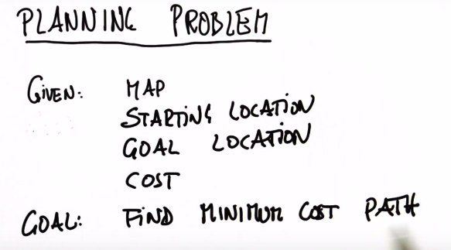

Assigning costs to actions and finding the cost assoctiated with the succesion of actions that leads from the starting position the goal position leads to a total cost for the entire path. Given an infinite number of paths that lead from the starting point to the goal point, we choose the path with the minimum cost, meaning the actions that make of the path have a minimum cost.

Example: Delivery services optimize their delivery routes so that very few left turns are required due to the fact that they require much more time than a right turn.

We want our path planning algorthm to give us the path with the minimum cost.

Search

(Discrete Path Planning, the world is a grid)
Breadth First Search
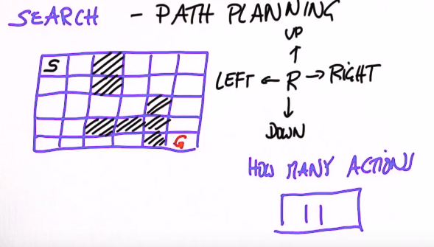

In order to write a program that can find us the path in this world from the Start to the Goal, we should think about naming each grid cell.
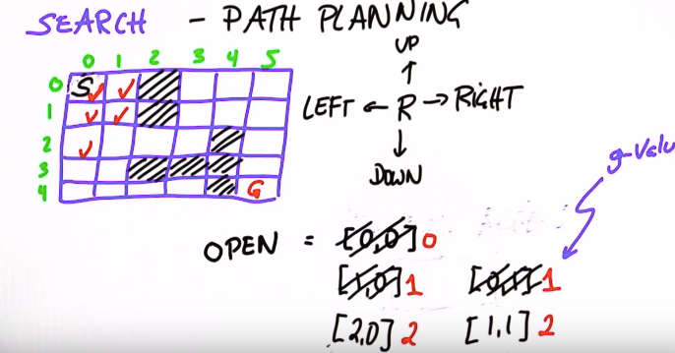

We can have a list nodes that we want to investigate further (also called Expand). We can then expand it, meaning we check each possible path from it. Example if we start at S, we are in the node (0,0) and at the next step we can be in (0,1) or (1,0), with each being 1 step (1 expand) or 1 cost.

Next we expand the one with the smallest g-value. In the algorthm, we also ensure that we dont add nodes to this list that have already been checked. This along with expanding the node with the lowest g-value will allow the open array to move towards the goal by taking all the the free space.

A* Search

The Sequence of steps is similar to Breadth First Search, and at the worst case A* Search is equivelent to Breadth First Search.

A* search is a Heuristic Search Algorithm, meaning that it finds the path to the goal quicker by using a Heuristic function to decide which branches to expand.

A Heuristic function is a function that ranks alternatives in a search algorithm at each branch based on available information to decide which branch to follow. It can be an approximate solution rather than an exact solution.

Using a heuristic function trades optimality, completeness, accuracy, or precision for speed.

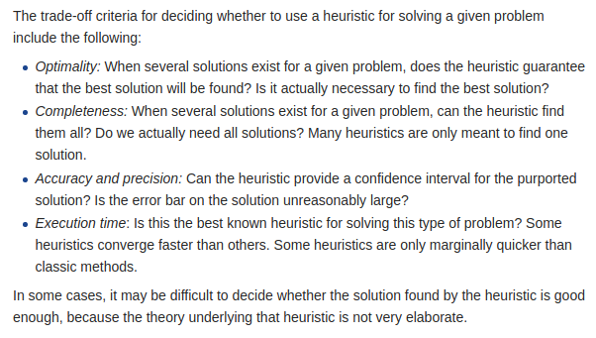
A Heuristic functions values are required to be less than or equal to the distance to a goal from each point.

For our grid example, the Heuristic function we will use has the number of actions required to reach the goal from each point in the grid without considering boundaries. The distances from each point to the goal without boundaries is garunteed to be less than or equal to the acutal distance to the goal from each node.

For each node, we dont only keep track of the g-value or cost to that step, but also the g-value plus the herustic value at that node.

When you expand, you will expand the node with the lowest g + h rather than the lowest g. This will lead to an Solution. This will make the algorithm move in a biased direction towards the goal.

Any heuristic search requires some information about the goal in order to find a heuristic.

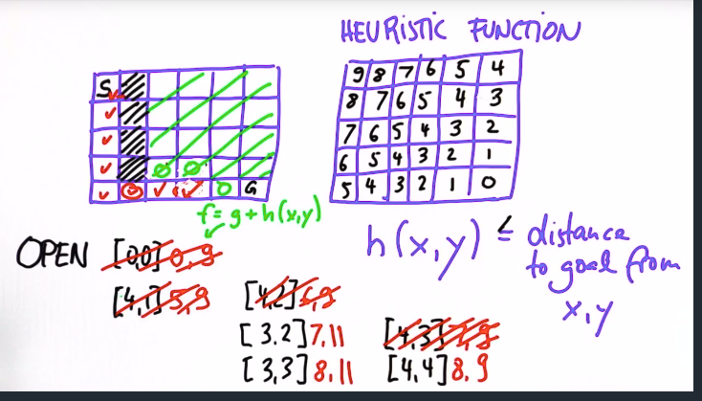

Alternative Method for Planning

Dynamic Programming

Given a map and a goal position, it will provide you the best path to the goal position from any starting point.

Currently we only considerd our actions being deterministic and not stochastic. This means the output of any action we take only has one possibility.

Dynamic Programmings ability to use any starting point makes it useful in a Stochastic Environment. We need a plan for every position instead of just the most likely one.

Dynamic Programing provides a plan for every position. For example, with the same grid as above, Dynamic Programming provides a Policy, which is the optimal action to reach the goal from every grid cell.

This algorithm is much more computationally involved then A*, but it is required for a Stochastic Environment.
Dynamic Programming will provide us with a Policy.

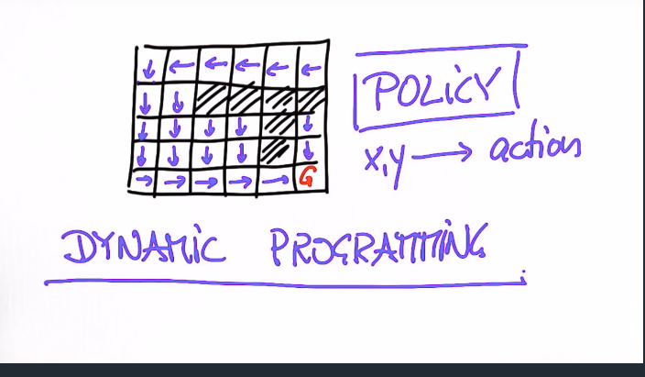

Initially instead of thinking about the optimal action at each gridcell, we can think about something called the Value Function.

It associates each grid cell, with the number of actions to the goal.

It is recursively calculated by taking the optimal neighbour, considering its value, and adding the cost it takes to get there from the current x,y.

The optimal control action can then be acquired by minimizing the value, which is called a hill-climbing action.

